Ass 02: Craps Game
IT 1090C Computer Programming I
Prof. Jason Geanuracos
Fall 2025

Ass 02 Craps Game
20 Points

Objectives:
- Conditional Structures in Java if, if else, cascaded if, nested if, while, do..while
- Random numbers in Java for simulations. Gaussian vs Linear Probability
- Testing. Make sure your programs run by testing them. Develop a testing regime.
- Students often ask, "Why craps?" well back in the day, everyone knew the rules for this simple dice game. We use it because it is a problem that includes an indefinite number of repetitions (i.e. rolling against the point) which you have to code with a regular while loop. It’s popular and can be found as a game anywhere.

Mini – Lecture: Random in Java
import java.util.Random; // must import Random (like we do Scanner)
Random rnd = new Random(); // create a Random object called rnd.
int rndBirthMonthOff = rnd.nextInt(12); // generates a random value from 0 – 11
int rndBirthMonth = rnd.nextInt(12) + 1; // What we want: 1 -12 so we shift it by adding 1
int dieOff = rnd.nextInt(6); // generates a random int between 0 and 5
int die = rnd.nextInt(6) + 1; // generates a random int between 1 and 6 what we want for dice!

int die1 = rnd.nextInt(6) + 1;
int die2 = rnd.nextInt(6) + 1;
int crapsRoll = die1 + die2; // Gaussian range from 2 to 12 as in rolling two dice

Assignment
Screenshot shortcut keys
- Windows: Alt + printScrn key puts image of desktop in clipboard. Then paste (ctrl+v) it into the document. You can also use Opt (Start) + Shift + s to bring up a cropping tool and paste that into your document. This may be easier. Also, you can hit Start + v to bring up the clipboard if you would like to screenshot multiple pictures and then paste all at once. Mac: Shift + Command + 3 or Shift + Command + 4 to capture a portion of the screen. Then, paste (command + v) it into the document.
Mac: Shift + Command + 3 or Shift + Command + 4 to capture a portion of the screen. Then, paste (command + v) it into the document.
The Rules of the Game:

  - There is an initial roll of 2 dice resulting in a sum of 2 – 12.
    - If the sum is 2, 3 or 12 it is called "craps" or "crapping out" and the game is over with a loss.
    - If the sum is 7 or 11 it is called a ‘natural’ and the game is over with a win.
    - For all other values, the sum becomes ‘the point’ and the user makes subsequent rolls until they either throw a 7 in which case they lose or they make the point sum in which case they win.
  - After a win or loss, the next player rolls the die for a new game. In our simulation, the program will simply ask the user if they want to continue to play.
  - For each roll show the value for each die and the sum.
  - For case i or ii above, indicate that the user either crapped out or won with a natural and then prompt to play again.
  - For case iii indicate that the sum is now the point. For each subsequent roll indicate the status of the result:
    - Trying for point
    - Made point and won. (Prompt user to play again.)
    - Got a seven and lost (Prompt user to play again.)

- Read through the Craps Game rules before you begin.
- I recommend the support video “While Loop” that will help you become much more familiar with loops and allow you to focus on the game.
- Create an IntelliJ project Ass_01_Craps and add it to GitHub source control. Code the Craps game as directed above. The computer will display the game using random numbers and will prompt the user to play again. In addition to the die result, the computer will display an interpretation of the results for each roll as specified.
EMBED SCREEN SHOTS HERE SHOWING YOUR PROGRAM RUNS: Include at least the 3 options above i .. iii

Trying for point and End in a loss

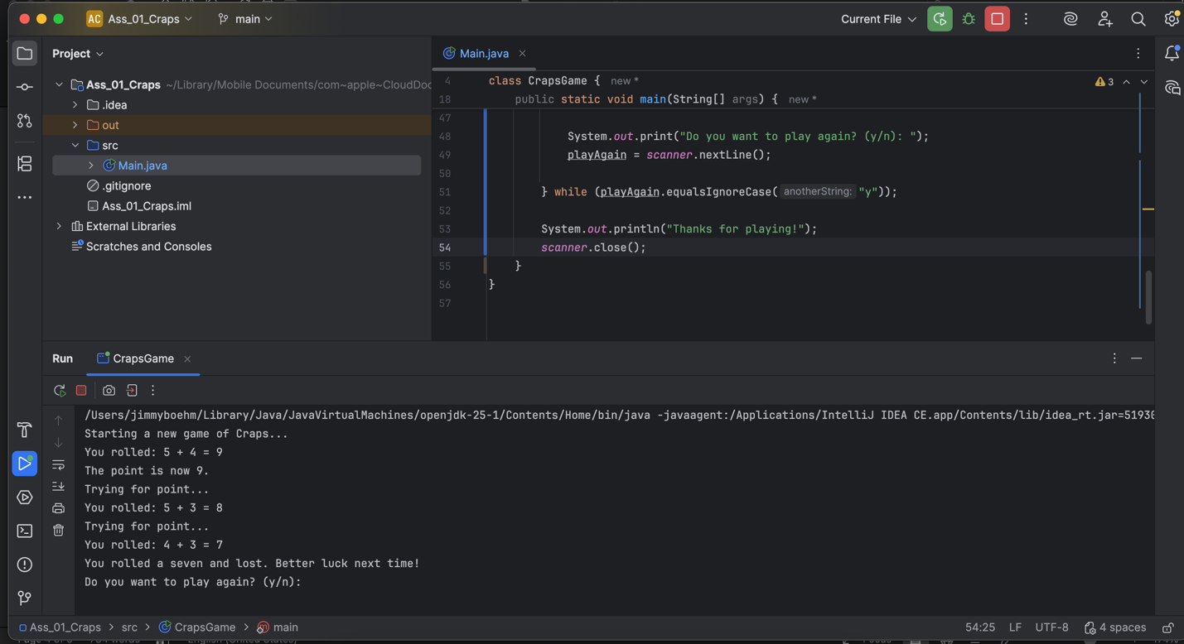
End in a Win
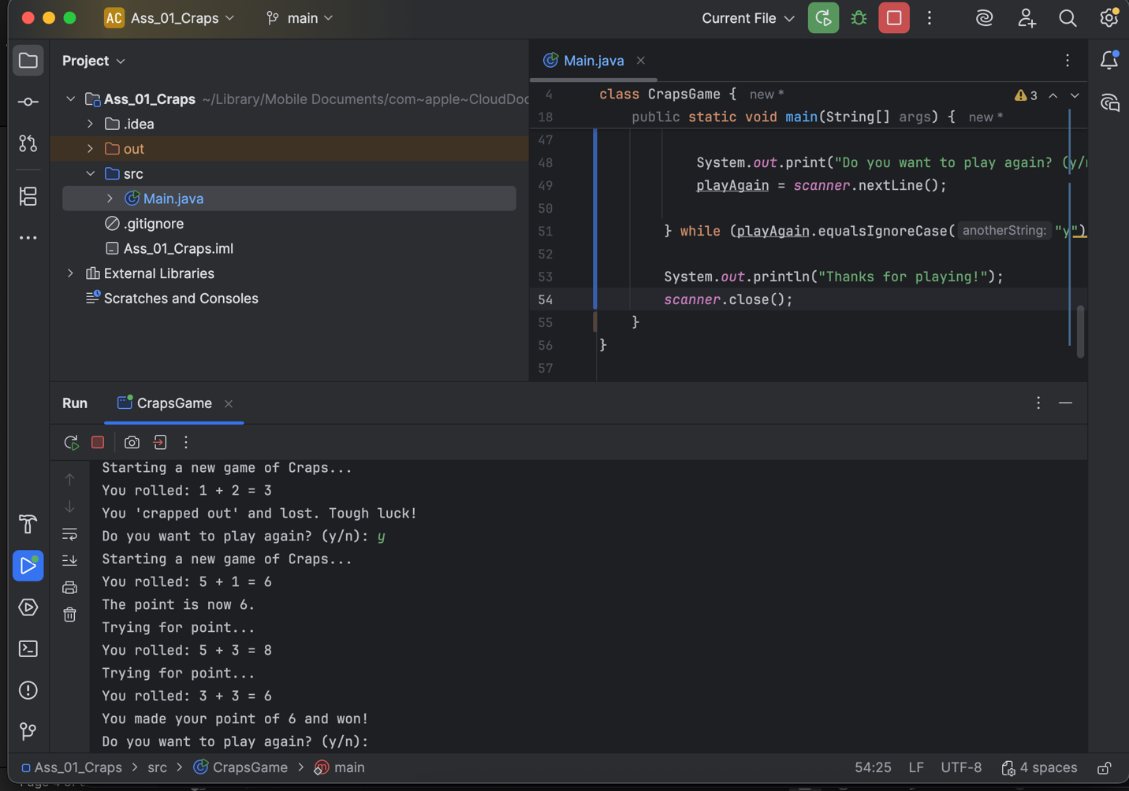

Post-Lab: Double-check Your Work
Now that you have completed the lab tasks, build constructive professional work habits by carefully rechecking your work, and abiding by the naming format and submission instructions.

Rename this file
Use the YourLastname_YourFirstname_Ass02_Craps.docx format to rename the MS Word docx; remember to replace "YourLastname" and "YourFirstname" with your actual names.

GitHub:
Provide/Paste the link to your GitHub repo.
https://github.com/boehmjs/Ass_01_Craps

Submit
Submit to Canvas using the assignments mechanism to upload your document. Don’t submit a link to your document.

